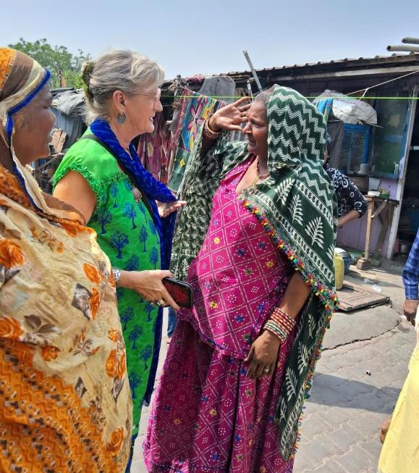



Kalakar Trust Activity Report,
Year April 2023 – March 2024

Index

- Kalakar Trust Overview
  - Kalakar Trust Vision
  - Kalakar Trust Mission

- Kalakar Trust Activities in April 2023- March 2024

  - Healthcare
    - Daily Healthcare Clinic: Patient Care Details
    - Health Support Camps
    - Hospital Operations and Admissions
    - Community Health Workers Support
      - Ante Natal Care
      - Home Visits
      - Hospital Visits
      - Health Awareness in Community and Clinic
      - Resource Distribution Support
        - Ration Distribution
        - Woolen and Blankets
        - Disability Equipment and Other Support
  - Education
    - Project Overview
      - Attendance (Annual and Monthly)
    - Computer Centre
      - BYJU’s Online Learning Program
    - Academic Classes
      - English Classes
      - Literacy Classes
    - Cutting and Stitching Classes
    - Art Classes
      - Music
      - Puppetry
      - Folk Dance
    - Parents Teachers Meeting
    - Co-curricular Activities and Celebrations
      - Festivals
      - Competitions and Cultural Programs
      - Art Programs
      - Summer Vacation Camp
      - Outings
    - Other Key Highlights and Achievements
      - School Admission Highlights
      - Computer and English Class Highlights
      - Literacy Batch
      - Special Batch

Kalakar Trust Activity Report, April 2023- March 2024

- Kalakar Trust Overview

Kalakar Trust is a non-government organization working for the artists residing in Delhi’s slums. The aim of the Trust is to provide medical care, education, income generation opportunities, and community management support.

The Trust was founded in 1992 by Mrs. Sterre Sharma, a painter, and her sister Mrs. Mei Zegers. The Trust has grown to benefit approximately 18,000 people. These beneficiaries include musicians, puppeteers, magicians, acrobats, and other marginalized residents of the former Kathputli Colony. The beneficiaries currently mostly reside in the Anand Parvat Transit Camp, waiting for their new housing that is being built at the site of the former Kathputli Colony. Approximately 450 families have been reallocated to DDA flats constructed for low-income groups in Narela, Delhi.

  - Kalakar Trust Vision
To be a leading agency and a model NGO in the preservation and the development of the vanishing traditional arts in India by focusing on the physical, mental, and professional needs of the artists.

  - Kalakar Trust Mission
To support the development of traditional artists through education, health actions, and improvement of economic opportunities. The focus of economic empowerment activities is on training, performing, producing, directing, choreography, costume management, and marketing of their arts so that they can have decent work and living conditions.
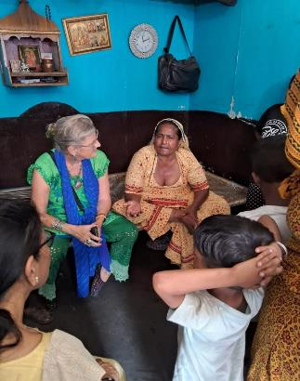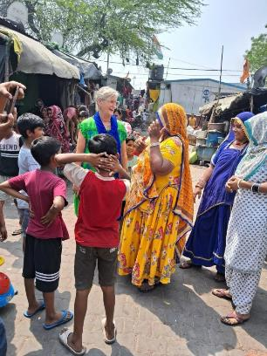

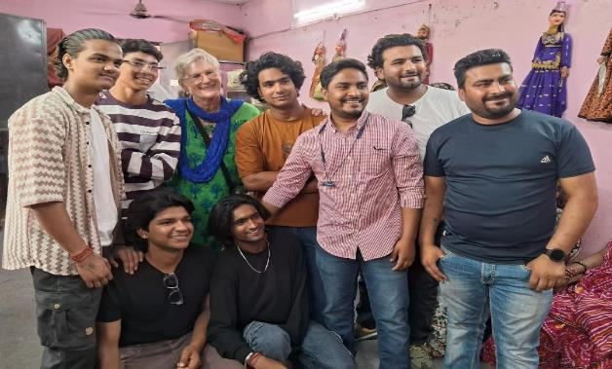

Photo: Sterre Sharma during her field visit with Patasi Devi, women, and young men who had graduated from Kalakar Vikas school

Detailed Report

2. Kalakar Trust Activities from April 2023 up to and including March 2024
The Kalakar Trust currently operates the following activities with the inhabitants of the transit camp at Anand Parvat:

  - Healthcare
The Kalakar Trust Clinic functions with:
• visiting Doctors,
• a Community Health Supervisor, and
• four Community Health Workers supported and trained by the Kalakar Trust

The clinic provides:
• free daily medical consultations and medicines to patients,
• monthly health check-up camps and health awareness sessions,
• support with sending patients to hospitals accompanied by Trust supported health workers,
• transportation to patients requiring operations,
• support with health monitoring follow-ups and post-surgery hospital visits.

Dr. T. U. Siddiqui conducts general health check-ups twice a week. He also refers patients to hospitals as needed.

Dr. Devangi Thaper and Dr. Monika assist with health check-ups of adolescent girls and women.

Shahjani, Nazia, Shanti, and Suman are the Kalakar Trust supported community health workers who accompany patients and pregnant women to hospitals (mostly to Lady Harding Hospital).

    - Daily Healthcare Clinic: Patient Care Details
Summary of direct support that the Kalakar Trust provided:
- Free medicines to 6,667 patients, who visited Dr Siddiqui during his 95 visits
- 7,328 patients received over the counter medications from Yogita (Medical Assistant).
- A total of 13,995 patients received free medicines during their OPD visits.

In addition, free medicines are provided on an on-going routine basis (daily) for:
- 41 patients who receive medicine for high blood pressure,
- 22 patients for high blood pressure and diabetes,
- 20 patients for diabetes,
- 3 patients for heart diseases,
- 1 patient for psychiatric issues, and,
- 1 patient for MDR Tuberculosis.

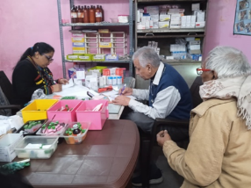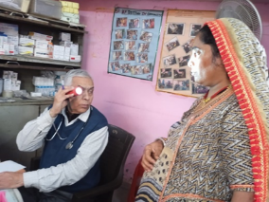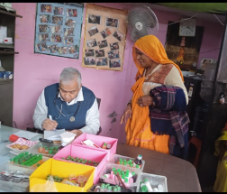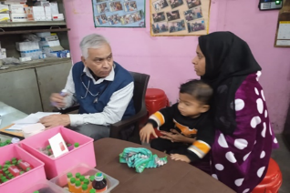
Photos: Clinic

    - Health Support Camps
Regular eye and ear health camps are organized with the help of Shroff Hospital and free operations are carried out when needed.

General health camps are organized by Dr. Siddiqui and referred patients are sent to government hospitals such as R.M.L. hospital, Lady Harding Hospital, Patel Hospital, Sir Ganga Ram Hospital, Safdarjung Hospital, and others.

Other medical camps such as on Dermatology, Neurology, and Orthopedic issues are also organized. During the period between April 2023 and March 2024. The Trust organized 7 health camps in Transit Camp Anand Parvat during the same period. A total of 410 people attended these camps.

Free medicines were distributed to the patients during the health camps. The patients purchased some of the medicines as their contribution to cover part of their costs . Patients needing additional care were referred to hospitals, including for eye operations. Dr. Siddiqui coordinated 6 times with a distributor of dermatology medicine who provided the patients with free medicines.

Photos: Eye camp

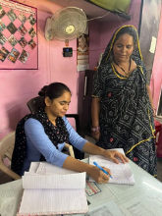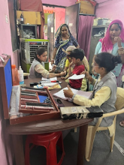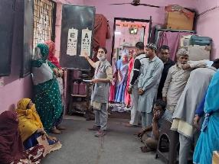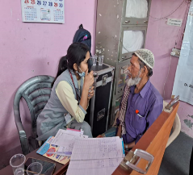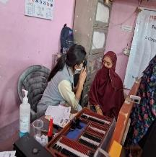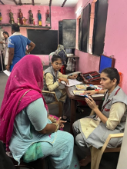

Photos: Bone Density camp
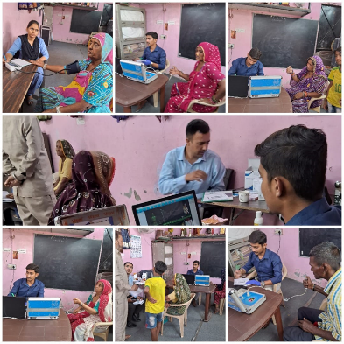

Volunteer doctors and Medical Centre support providers:

- Shroff Hospital, New Medical Centre, Dr. Sabrina Jain, Dr. Nidhi Gaur, Dr. Edison Thomas, Dr. T.U Siddiqui and Jeet Society.

- Mr. Avishesh Pandey, Ms. Sarwat, Mr. Muzamil, Mr. Gulista, Ms., Mr. Hafiza, Mr. Prem, Mr. M Shekhar Verma, and Mr. Manish Kumar provided technical help in these camps.

    - Hospital Admissions and Operations

The Kalakar Trust Clinic facilitated 68 Operations between April 2023- March 2024 in local hospitals.

Photos: Eye Operation
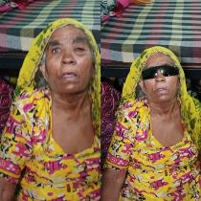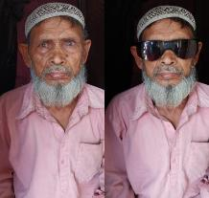

Operation Details:
S.N | Name | Age | M/F | House no | Date of operation | Disease | Hospital
1 | Chanda | 70 | F | 1357 | 4/3/2023 | Cataracts | Shroff Hospital Karol Bagh
2 | M.Hamid | 45 | M | 1864 |  | Cataracts | Shroff Hospital Karol Bagh
3 | Kartik | 10 | M |  | 4/25/2023 | Burn | R.M.L Hospital
4 | Piyush | 6 | M | 29 | 4/28/2023 | Intestinal problems | R.M.L Hospital
5 | Gayatri/Dinesh |  |  |  | 4/26/2023 | Family Planning | Girdhari Lal Hospital
6 | Sunita/Birju |  |  |  | 4/3/2023 | Family Planning | Girdhari Lal Hospital
7 | Abdas | 60 | F | 1620 | 5/6/2023 | Cataracts | Guru Nanak Hospital
8 | M.Naieem Ahmed | 55 | M | 931 | 5/15/2023 | Cataracts | Shroff Hospital Karol Bagh
9 | Bimla | 45 | F | 1131 | 5/25/2023 | Cataracts | Shroff Hospital Karol Bagh
10 | Zahid Alam | 60 | M | 1936 | 5/27/2023 | Cataracts | Shroff Hospital Daryaganj
11 | Zibi | 60 | F | 1453 | 5/25/2023 | Cataracts | Shroff Hospital Karol Bagh
12 | Badami | 75 | F | 1129 | May-23 | Diabetes- One Leg Removed | New Medical Center
13 | Sangeeta/Rahul |  |  | 1225 | 5/11/2023 | Family Planning | Patel Hospital
14 | Sangeeta | 40 | F | 476 | 6/6/2023 | Cataracts | Sir Ganga Ram Hospital
15 | Asim | 60 | M | 2226 | 6/13/2023 | Cataracts | Shroff Hospital Karol Bagh
16 | Suhana | 55 | F | 1977 | 6/15/2023 | Gall Bladder Stones | R.M.L Hospital
17 | Ashwake | 60 | M | 1947 | 6/5/2023 | Cataracts | Patel Hospital
18 | Rahul | 23 | M | 1199 | 6/8/2023 | Hernia | Patel Hospital
19 | Naieem Ahemed | 60 | M | 931 | 6/6/2023 | Cataracts | Shroff Hospital Karol Bagh
20 | Maya | 50 | F | 1229 | 6/6/2023 | Cataracts | Shroff Hospital Karol Bagh
21 | Shallu | 22 | F | 1122 | 7/27/2023 | Squint Eye (strabismus) | Shroff Hospital Karol Bagh
22 | Sattok Bhatt | 70 | M | 699 | 7/28/2023 | Cataracts | Shroff Hospital Karol Bagh
23 | Gummana | 72 | F | 226 | 7/25/2023 | Cataracts | Shroff Hospital Karol Bagh
24 | Shanker | 60 | M | 2141 | 7/31/2023 | Cataracts | Shroff Hospital Karol Bagh
25 | Siddhart | 60 | M | 2492 | 7/24/2023 | Cataracts | Shroff Hospital Karol Bagh
26 | Bahadur | 55 | M | 1255 | 7/27/2023 | Cataracts | Shroff Hospital Karol Bagh
27 | Pooja/Sonu |  |  | 1254 | 7/31/2023 | Family Planning | Girdhari Lal Hospital
28 | Rakhi/Shanker |  |  | 48 | 7/20/2023 | Family Planning | Sir Ganga Ram Hospital
29 | Sayra Bano | 55 | F | 577 | 8/1/2023 | Cataracts | Shroff Hospital Karol Bagh
30 | Vijay | 52 | M | 533 | 8/1/2023 | Cataracts | Shroff Hospital Karol Bagh
31 | Rajesh | 35 | M | 141 | 8/3/2023 | Ear Surgery | Sir Ganga Ram Hospital
32 | Sunil Bhatt | 55 | M | 703 | 8/7/2023 | Cataracts | Shroff Hospital Karol Bagh
33 | Rehmati | 60 | F | 2023 | 8/7/2023 | Cataracts | Shroff Hospital Karol Bagh
34 | Sadre Alam | 55 | M | 1987 | 8/7/2023 | Cataracts | Shroff Hospital Karol Bagh
35 | Vishal | 35 | M | 405 | 8/16/2023 | Leg Surgery (following Accident) | Sir Ganga Ram Hospital
36 | Shanker | 60 | M | 2141 | 8/2/2023 | Cataracts | Shroff Hospital Karol Bagh
37 | Baldev Singh | 60 | M | 2708 | 9/8/2023 | Cataracts | Shroff Hospital Daryaganj
38 | Maya | 55 | F | 1229 | 9/8/2023 | Retinal Detachment | Shroff Hospital Daryaganj
39 | Chand Bai | 62 | F | 667 | 9/10/2023 | Cataracts | Shroff Hospital Karol Bagh
40 | Ramesh Tondon |  | M | 1214 | 10/27/2023 | Angioplasty | R.M.L Hospital
41 | Gattu | 50 | M | 561 | 11/17/2023 | Kidney Stone | Phero Hospital
42 | Anita | 35 | F | 544 | 11/2/2023 | Cancer of the Mouth | Sir Ganga Ram Hospital
43 | Maya | 55 | F | 1229 | 12/18/2023 | Cataracts | Shroff Hospital Karol Bagh
44 | Kavita/Arjun |  |  | 181 | 12/15/2023 | Family Planning | Girdhari Lal Hospital
45 | Meenakshi/Akash |  |  | 113 | 12/15/2023 | Family Planning | Girdhari Lal Hospital
46 | Anita/Vicky |  |  | 1348 | 12/21/2023 | Family Planning | Girdhari Lal Hospital
47 | Noorjaha | 65 | F | 2135 | 1/22/2024 | Cataracts | Shroff Hospital Karol Bagh
48 | Gopi | 45 | F | 735 | 1/29/2024 | Cataracts | Shroff Hospital Karol Bagh
49 | Akhilesh | 48 | F | 424 | 1/28/2024 | Cataracts | Ghaziabad PVT. Hospital
50 | Rakhi/Birju |  |  | 355 | 1/12/2024 | Family Planning | Phero Hospital
51 | Vidhya | 70 | F | 951 | 2/1/2024 | Cataracts | Shroff Hospital Karol Bagh
52 | Kaushalya | 65 | F | 933 | 2/1/2024 | Cataracts | Shroff Hospital Karol Bagh
53 | Asha Begum | 65 | F | 931 | 2/8/2024 | Cataracts | Shroff Hospital Karol Bagh
54 | Bansi | 60 | M | 697 | 2/9/2024 | Cataracts | Shroff Hospital Karol Bagh
55 | Ghumma Devi | 65 | F | 768 | 2/9/2024 | Cataracts | Shroff Hospital Karol Bagh
56 | Maya | 65 | F | 1229 | 2/15/2024 | Retinal Detachment | Shroff Hospital Daryaganj
57 | Soni | 45 | F | 280 | 2/22/2024 | Cataracts- Laser | Shroff Hospital Karol Bagh
58 | Navratan Bhatt | 53 | M | 53 | 2/23/2024 | Cataracts | Shroff Hospital Karol Bagh
59 | Shanno | 45 | F | 1201 | 2/9/2024 | Kidney stone removal | Phero Hospital
60 | Chinna | 65 | F | 544 | 2/12/2024 | Stone removal , Gall Bladder | Sir Ganga Ram Hospital
61 | Zafir | 54 | M | 2016 | 3/11/2024 | Cataracts | Shroff Hospital Karol Bagh
62 | Shamshad Begum | 50 | F | 2036 | 3/13/2024 | Cataracts | Shroff Hospital Karol Bagh
63 | Prem Devi | 45 | F | 952 | 3/13/2024 | Cataracts | Shroff Hospital Karol Bagh
64 | Zareena | 35 | F | 412 | 3/5/2024 | Removal | New Medical Center
65 | Dropati | 50 | F | 922 | 3/13/2024 | Lump in Stomach | Phero Hospital
66 | Madhuri | 60 | F | 1052 | 3/31/2024 | Cataracts | Shroff Hospital Karol Bagh
67 | Devraj | 73 | M | 2645 | 3/28/2024 | Cataracts | Shroff Hospital Karol Bagh
68 | Geeta | 54 | F | 336 | 3/28/2024 | Cataracts | Shroff Hospital Karol Bagh

    - Community Health Workers Support
Community Health Workers conduct regular home visits, accompany and support patients on hospital visits, facilitate hospital procedures, and provide health talks. The following are the details for the period from April 2023 through March24:

      - Ante Natal Care
- Health workers monitored 137 pregnancies.
- They facilitated 60 deliveries in hospitals, while 23 were delivered by local trained Dais.

49 boys and 34 girls were delivered.

      - Home Visits by Health Workers
Three health workers and a health supervisor conducted 16,354 home visits in 2023-24.

 | Community Health Workers
Month | Naziya | Shahzani | Shanti | Naseema
April | 339 | 267 | 170
May | 361 | 483 | 551
June | 619 | 518 | 564
July | 497 | 108 | 410
August | 428 | 337 | 323
September | 495 | 597 | 619
October | 519 | 456 | 586
November | 321 | 354 | 416
December |  | 447 | 369 | 448
January |  | 436 | 265 | 466
February |  | 657 | 694 | 734
March |  | 436 | 544 | 520
 |  |  |  |  | Total Visits
Total Visits | 3579 | 5096 | 5511 | 2168 | 16354
Average | 447 | 425 | 459 | 542

      - Hospital Visits by Health Workers
The community health workers took 468 patients to the hospitals as detailed below:

Hospital Visit
Month | Health Worker | Hospital | No. of Patient | Mode of Conveyance
April | Shanti | Girdhari Lal Hospital | 1 | Bus
 |  | Girdhari Lal Hospital | 2 | Bus
 |  | Patel Hospital | 4 | Rikshaw
 |  | Viklang Sewa Samiti | 2 | Bus
 |  | Viklang Sewa Samiti | 2 | Kalakar Van
 |  | Patel Hospital | 1 | Rikshaw
 |  | R.M.L Hospital | 2 | Bus
 | Shahazani | R.M.L Hospital | 2 | Bus
 |  | Viklang Sewa Samiti | 3 | Rikshaw
 |  | Patel Hospital | 4 | Kalakar Van
 | Naziya | Shroff Hospital Karol Bagh | 5 | Rikshaw
 |  | Patel Hospital | 6 | Kalakar Van
 |  | Shroff Hospital Karol Bagh | 4 | Rikshaw
May | Shanti | Patel Hospital | 2 | Bus
 | Shanti | B.L.Kapoor Hospital | 1 | Bus
 | Shanti | R.M.L Hospital | 8 | KalakarVan
 | Shanti | Lady Harding Hospital | 4 | Auto Rikshaw
 | Shanti | Girdhari Lal Hospital | 4 | Kalakar Van
 | Shanti | Shroff Hospital Daryaganj | 4 | Rikshaw
 | Shahzani | Patel Hospital | 4 | Kalakar Van
 | Shahzani | Shroff Hospital Karol Bagh | 7 | Kalakar Van
 | Shahzani | Shroff Hospital Karol Bagh | 4 | Kalakar Van
 | Shahzani | R.M.L Hospital | 5 | Kalakar Van
 | Naziya | Shroff Hospital Karol Bagh | 5 | Rikshaw
 | Naziya | Patel Hospital | 3 | Rikshaw
 | Naziya | Patel Hospital | 4 | Kalakar Van
June | Shanti | Shroff Hospital Daryaganj | 6 | Kalakar Van
 |  | R.M.L Hospital | 1 | Auto Rikshaw
 |  | Deen Dayal Upadhaya | 2 | Kalakar Van
 |  | Deen Dayal Upadhaya | 1 | Auto Rikshaw
 | Shahzani | R.M.L Hospital | 3 | Rikshaw
 |  | Patel Hospital | 4 | Rikshaw
 | Naziya | Patel Hospital | 4 | Rikshaw
 |  | Patel Hospital | 5 | Kalakar Van
 |  | R.M.L Hospital | 2 | Kalakar Van
July | Shanti | Deen Dayal Upadhaya | 4 | Auto Rikshaw
 |  | Girdhari Lal Hospital | 2 | Auto Rikshaw
 | Naziya | R.M.L Hospital | 7 | Kalakar Van
 | Shahzani | Shroff Hospital Karol Bagh | 9 | Kalakar Van
 |  | Shroff Hospital Karol Bagh | 4 | Rikshaw
 |  | Patel Hospital | 3 | Kalakar Van
August | Shanti | Shroff Hospital Daryaganj | 2 | Bus
 |  | Girdhari Lal Hospital | 1 | Bus
 |  | Deen Dayal Upadhaya | 5 | Rikshaw
 | Shahzani | Patel Hospital | 6 | Kalakar Van
 |  | Lady Harding Hospital | 3 | Rikshaw
 |  | Patel Hospital | 3 | Kalakar Van
 | Naziya | Viklang Sewa Samiti | 5 | Kalakar Van
 |  | Shroff Hospital Karol Bagh | 6 | Rikshaw
 |  | Patel Hospital | 4 | Rikshaw
September | Naziya | Patel Hospital | 6 | Rikshaw
 |  | Patel Hospital | 5 | Rikshaw
 |  | Patel Hospital | 5 | Kalakar Van
 | Shanti | Shroff Hospital Karol Bagh | 2 | Bus
 |  | R.M.L Hospital | 8 | Rikshaw
 |  | Patel Hospital | 5 | Bus
 | Shahzani | Acharya Bhikhshu Hospital | 4 | Rikshaw
 |  | Patel Hospital | 5 | Kalakar Van
 |  | Shroff Hospital Karol Bagh | 8 | Rikshaw
October | Shanti | Patel Hospital | 7 | Rikshaw
 |  | Patel Hospital | 7 | Kalakar Van
 |  | Shroff Hospital Karol Bagh | 8 | Rikshaw
 | Shahzani | Patel Hospital | 3 | Rikshaw
 |  | Patel Hospital | 4 | Kalakar Van
 |  | Kalawati Hospital | 7 | Rikshaw
 | Naziya | Patel Hospital | 5 | Rikshaw
 |  | Patel Hospital | 6 | Rikshaw
 |  | Patel Hospital | 5 | Auto Rikshaw
November | Shanti | Shroff Hospital Karol Bagh | 3 | Rikshaw
 |  | Patel Hospital | 5 | Rikshaw
 |  | Patel Hospital | 4 | Rikshaw
 | Shahzani | Acharya Bhikhshu Hospital | 4 | kalakarVan
 |  | Shroff Hospital Karol Bagh | 7 | Rikshaw
 |  | Patel Hospital | 5 | Rikshaw
 | Naziya | Patel Hospital | 6 | Rikshaw
 |  | Patel Hospital | 4 | Rikshaw
December | Shanti | Patel Hospital | 4 | Auto Rikshaw
 |  | Girdhari Lal Hospital | 1 | Auto Rikshaw
 |  | Deen Dayal Upadhaya | 1 | Auto Rikshaw
 |  | R.M.L Hospital | 8 | Rikshaw
 | Shahzani | Patel Hospital | 4 | KalakarVan
 |  | Lady Harding Hospital | 1 | Auto Rikshaw
 |  | Deen Dayal Upadhaya | 7 | Rikshaw
 | Naziya | Patel Hospital | 4 | Kalakar Van
 |  | Lady Harding Hospital | 5 | Rikshaw
January | Naseema | Patel Hospital | 5 | Rikshaw
 |  | Patel Hospital | 2 | Kalakar Van
 |  | Shroff Hospital Karol Bagh | 2 | KalakarVan
 | Shahzani | Shroff Hospital Karol Bagh | 5 | Rikshaw
 |  | Patel Hospital | 2 | Kalakar Van
 |  | Shroff Hospital Karol Bagh | 4 | Rikshaw
 | Shanti | Patel Hospital | 6 | Rikshaw
 |  | Patel Hospital | 4 | Rikshaw
 |  | Acharya Bhikhshu Hospital | 5 | Rikshaw
February | Shanti | Patel Hospital | 1 | Auto Rikshaw
 |  | R.M.L Hospital | 4 | Rikshaw
 |  | Patel Hospital | 4 | KalakarVan
 | Naseema | Shroff Hospital Karol Bagh | 4 | Kalakar Van
 |  | Shroff Hospital Karol Bagh | 5 | Rikshaw
 | Shahzani | Patel Hospital | 5 | Kalakar Van
 |  | Shroff Hospital Karol Bagh | 5 | Kalakar Van
 |  | Shroff Hospital Karol Bagh | 3 | Rikshaw
March | Shanti | Patel Hospital | 2 | Auto Rikshaw
 |  | Girdhari Lal Hospital | 5 | Kalakar van
 |  | Patel Hospital | 3 | Rikshaw
 | Shahzani | Shroff Hospital Karol Bagh | 4 | Rikshaw
 |  | Shroff Hospital Karol Bagh | 5 | Rikshaw
 |  | Patel Hospital | 4 | Rikshaw
 | Naseema | Patel Hospital | 7 | Rikshaw
 |  | Shroff Hospital Karol Bagh | 5 | Rikshaw
 |  | Patel Hospital | 2 | Auto Rikshaw
 |  | R.M.L Hospital

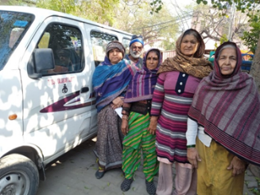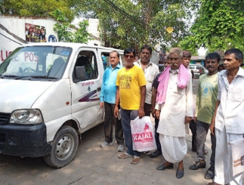
Photos: Patients going to hospital with the Kalakar Trust’s van

      - Health Awareness in Community and Clinic
49 community meetings and 24 clinic sessions on health awareness were conducted. Details as below:

Health Awareness Meetings in theCommunity
Date | Meeting Area/Block | Topic | Attendance
4/3/2023 | B | Skin Care | 10
4/13/2023 | C | Skin Care | 12
4/17/2023 | D | Skin Care | 13
4/21/2023 | A | Skin Care | 10
5/3/2023 | B | Skin Care | 12
5/13/2023 | C | Skin Care | 10
5/27/2023 | F | Skin Care | 10
5/31/2023 | G | Skin Care | 10
6/1/2023 | H | Diarrhea & Vomiting | 12
6/9/2023 | G | Diarrhea & Vomiting | 13
6/14/2023 | E | Diarrhea & Vomiting | 10
6/20/2023 | F | Diarrhea & Vomiting | 14
6/26/2023 | D | Diarrhea & Vomiting | 12
7/5/2023 | C | Eye infections | 15
7/14/2023 | B | Eye Infections | 12
7/26/2023 | A | Eye Infections | 10
7/28/2023 | D | Eye Infections | 12
8/2/2023 | G | Eye Infections | 12
8/8/2023 | E | Eye Infections | 15
8/14/2023 | F | Eye Infections | 20
8/19/2023 | D | Eye Infections | 13
9/4/2023 | E | B.P. & Heart Diseases | 14
9/12/2023 | H | B.P. & Heart Diseases | 10
9/23/2023 | G | B.P. & Heart Diseases | 13
9/19/2023 | F | B.P. & Heart Diseases | 14
10/4/2023 | C | Cold & Cough | 12
10/11/2023 | A | Cold & Cough | 15
10/20/2023 | D | Cold & Cough | 13
10/24/2023 | B | Cold & Cough | 14
11/2/2023 | E | Child Care | 12
11/7/2023 | F | Child Care | 15
11/10/2023 | B | Child Care | 12
11/20/2023 | C | Child Care | 13
12/2/2023 | C | Pregnancy Care | 12
12/9/2023 | A | Pregnancy Care | 15
12/14/2023 | D | Pregnancy Care | 13
12/23/2023 | E | Pregnancy Care | 12
1/11/2024 | A | Cold & Cough | 10
1/3/2024 | B | Cold & Cough | 13
1/20/2024 | E | Cold & Cough | 12
1/30/2024 | F | Cold & Cough | 11
2/2/2024 | C | Cold & Cough | 10
2/8/2024 | D | Cold & Cough | 12
2/22/2024 | E | Cold & Cough | 12
2/27/2024 | F | Cold & Cough | 10
3/2/2024 | A | Child Care | 10
3/7/2024 | B | Child Care | 12
3/13/2024 | C | Child Care | 11
3/26/2024 | D | Child Care | 12
 | Total Meetings | 49

Health Awareness Meeting-Clinic
Date | Topic | Talk by | Total viewers
5/22/2023 | Menstruation & White Discharge | Shazani & Naziya | 15
5/26/2023 | Menstruation & White Discharge |  | 20
6/6/2023 | Menstruation & White Discharge |  | 20
6/13/2023 | Menstruation & White Menstruation Discharge |  | 15
6/22/2023 | Menstruation & White Discharge |  | 12
7/13/2023 | Menstruation & White Discharge |  | 15
7/24/2023 | Menstruation & White Discharge |  | 12
8/10/2023 | B.P Screening |  | 20
8/21/2023 | B.P. Screening |  | 15
9/11/2023 | Skin Care |  | 25
9/25/2023 | Skin Care |  | 30
10/5/2023 | Child Care |  | 20
10/12/2023 | Child Care |  | 25
11/6/2023 | B.P. & Heart Diseases |  | 25
11/16/2023 | B.P. & Heart Diseases |  | 22
12/7/2023 | Skin Care |  | 20
12/21/2023 | Skin Care |  | 22
1/9/2024 | Menstruation & Cleanliness |  | 15
1/23/2024 | Menstruation & Cleanliness |  | 25
2/5/2024 | Menstruation & Cleanliness |  | 20
2/23/2024 | Menstruation & Cleanliness |  | 20
3/9/2024 | Cleanliness |  | 20
3/23/2024 | Cleanliness |  | 12

Photos: Health Awareness Community Meets

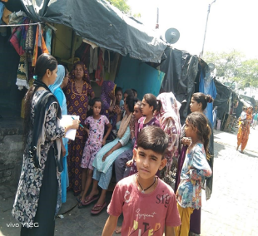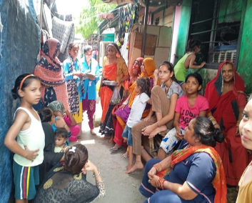

      - Resource Distribution Support
The community health workers also provide support with distribution of resources such as food rations, blankets, and disability assistance equipment.

        - Ration Distribution
The Trust distributes food to a few old women, widows, and patients who are in special need. In year 2023-24, 15 families received food support on a regular basis, and 200 families received one time

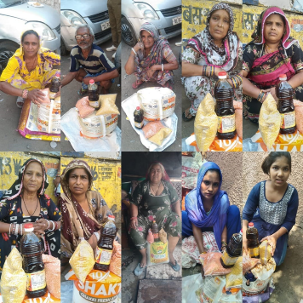

        - Woolen and Blanket Distribution
100 women and 100 men received woollen blankets during the reporting period.

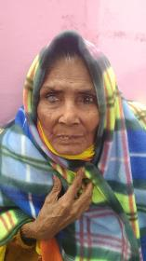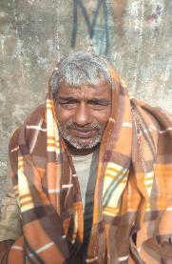

        - Disability Equipment and Other Support
Some patients were given equipment to make their life easier as follows:
- Two people were provided with wheelchairs,
- Two patients received walkers,
- One child received callipers,
- One woman was given an artificial leg after her leg had to be amputated due to infection,
- One man and one child received hearing aids, and
- One woman received dentures, she contributed half of the cost.

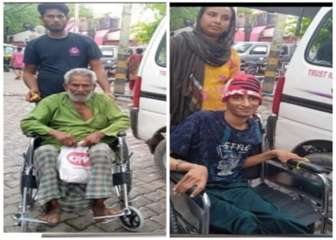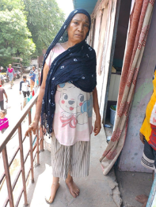
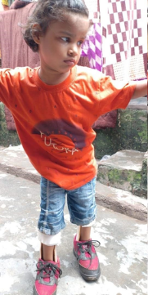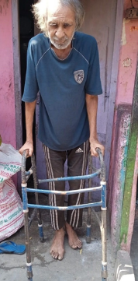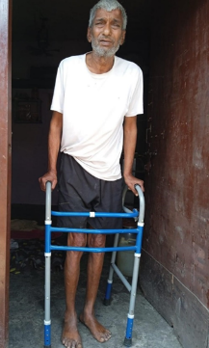

  - Education
The Trust has operated a school for the children of the Kathputli Colony since 1992. After the demolition of the Colony, the Trust is now working in the transit camp. Given the space constraints, DDA has provided a small area to continue education support. With this limited space, the Trust is operating computer classes and providing academic & art coaching to students from class 4 to 10.

The Kalakar Trust Education project has:
- 5 teachers
- 1 counsellor, and
- 3 art teachers (puppeteer, harmonium teacher, and dance teacher)

    - Project Overview

The Kalakar Trust provides after-school and other coaching to school-going students who need special support. The Trust also provides literacy classes for school dropout students and for some women from the community. Students drop out of formal schooling for different reasons and need special support outside of school.

Currently, 235 students are admitted in the coaching school. Classes register an average daily attendance of 134 students in accordance with their need and time availability.

Class | Average Present Students | Maximum | Minimum
4th | 8 | 12 | 3
5th | 14 | 14 | 8
6th | 13 | 15 | 7
7th | 9 | 11 | 6
8th | 8 | 10 | 3
9th | 9 | 11 | 3
10th | 2 | 4 | 1
Literacy Batch | 47 | 62 | 35
General Education Batch | 24 | 27 | 6

      - Attendance (Annual and Monthly)

Class | APR | MAY | JUNE | JULY | AUG | SEP | OCT | NOV | DEC | JAN | FEB | MAR
4th | 3 | 6 | 12 | 5 | 7 | 8 | 8 | 8 | 7 | 8 | 7 | 6
5th | 14 | 14 | 13 | 12 | 12 | 11 | 12 | 11 | 12 | 13 | 11 | 8
6th | 15 | 13 | 10 | 11 | 12 | 12 | 12 | 12 | 10 | 10 | 7 | 7
7th | 9 | 9 | 6 | 7 | 10 | 8 | 10 | 9 | 7 | 11 | 7 | 6
8th | 10 | 8 | 8 | 7 | 7 | 8 | 7 | 6 | 5 | 4 | 3 | 3
9th | 9 | 9 | 1 | 11 | 10 | 9 | 9 | 10 | 8 | 8 | 8 | 7
10th | 1 | 1 | 4 | 1 | 1 | 1 | 1 | 1 | 1 | 1 | 1 | 1
Literacy Batch | 42 | 35 | 35 | 37 | 45 | 47 | 52 | 50 | 62 | 54 | 52 | 49
General Batch | 20 | 20 | 19 | 27 | 27 | 22 | 18 | 12 | 12 | 10 | 8 | 6

    - Computer Centre
  - The computer centre is operated with 13 Computers, 2 Printers, 2 Scanners, 2 music systems, and one projector
  - An internet access facility is available for the students.
  - Two teachers provide computer classes - Ms. Insia Mursalin and Mr. Ibran (Alumni).
  - 42 students are enrolled in the Basic & Advanced computer courses, all students attend the general computer class.
  - Topics taught: Basic Windows, Operating MS Paint, Microsoft Word, Microsoft PowerPoint, Microsoft Excel, Photoshop, Coral Draw, Page Maker, Web Designing, Internet Exposure and Computer Languages

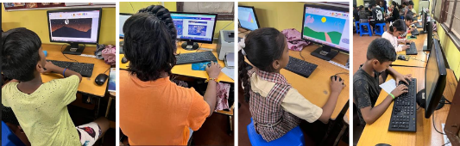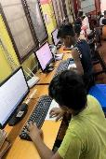

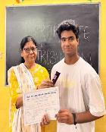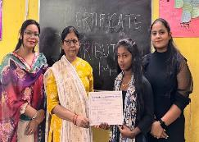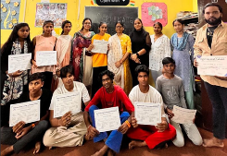

  - A special course entitled “E-marketing Course” has been designed especially for artists so that they can more effectively promote their art/business.



      - BYJU’s Learning Program

Eighteen computer tablets are provided to implement BYJU’ Educational Packages from class 4th to class 10, along with 18 headphones. The required set of learning books are provided by BYJU.

    - Academic Classes
  - Academic classes are conducted to improve learning and conceptual clarity of students’ academic syllabus. All the subjects are taught by skilled teachers.
  - Teachers are Ms. Shivani (Education Project Supervisor); Ms. Sushma & Ms. Ashish provide extra study classes.
  - After watching BYJU’s content, the teachers engage in revision classes to better understand the study topics,
  - Teachers provide formal tests to the students. Progress reports are provided to the parents via regular Parent Teacher Meetings.

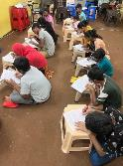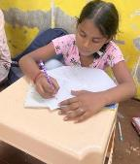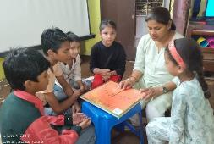

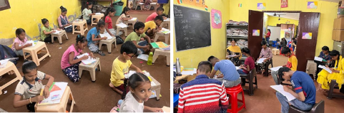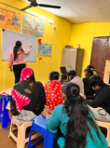

      - English Classes
More than 40 students are enrolled in the Kalakar Trust sponsored English Classes. They are given an opportunity to learn English through a range of classroom activities.

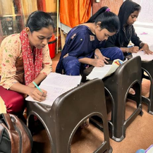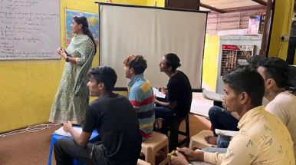

      - Literacy Classes
We provide special literacy classes for students who never went to school or dropped out of school at an early stage and are not capable of reading and writing. This literacy batch was primarily started to support adolescents. 52 students were enrolled during the current reporting period with a daily average attendance of 27 students.

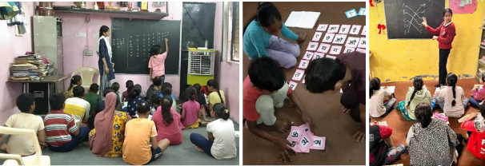

    - Cutting and Tailoring Classes

- 45 girls were enrolled a tailoring/stitching course during the current reporting period.

- 22 have completed the course and earned a completion certificate along with a gift to mark their achievement.

- After completing the course, a few of these girls have already started earning from tailoring jobs/ stitching clothes. Others use their knowledge to avoid tailoring expenses and save money by sewing their own clothes and those of their family as needed.

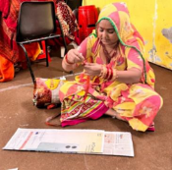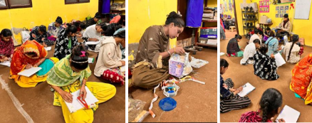

Girls with certificate of completion
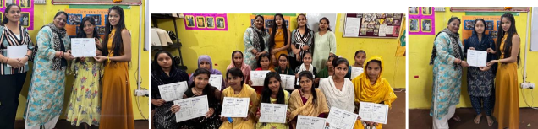

    - Art Classes
It should be noted that art class students attend classes depending on their availability. Non-attendance does not mean lack of interest but rather is usually due to the students' need to take care of other obligations.

      - Music Classes
Community Artist Mr. Jagdish Bhatt conducts a music class. He has enrolled 35 students with an average attendance of 18 students.

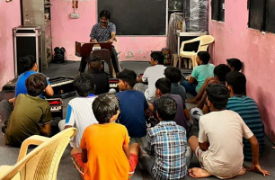

      - Puppetry Classes
Community Artist Mr. Lala Bhatt conducts the puppetry class. He has enrolled 40 students with an average attendance of 22 students.

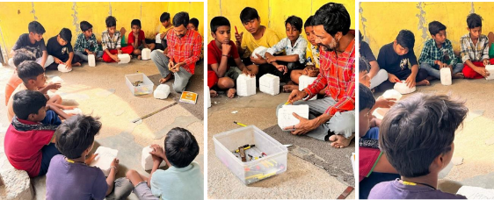

      - Folk Dance Classes
Community Artist Mrs. Suresh Bai conducts the Folk Dance class. He has enrolled 42 students with an average attendance of 25 students

    - Parents Teachers Meeting
The Trust conducts Parent Teacher Meetings to provide parents with feedback on their student’s performance. This enables continuous improvement of the students’ abilities. Parents are informed of their child(ren)’s results, areas of needed improvement, and next focus steps. The assessment is based on:
• Marks
• Attendance regularity
• Punctuality
• Class Behaviour

Such interactions bring about useful changes in the ways in which parents can support their children to improve their learning.

Between April 2022 and March 2023, we 4 Parents Teacher Meetings were held.

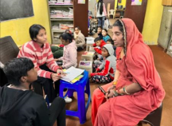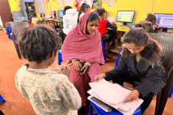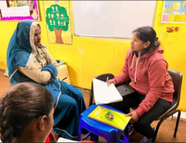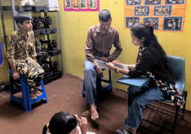

    - Co-curricular Activities and Celebrations
      - Festival Celebrations
The Trust organises some activities to ensure that the students understand the importance of different cultural festivals. This motivates the students and allows them to increase their respect for their culture. These activities also motivate them to join the coaching and literacy classes. Activities were held for the following:
- Independence Day Celebration
- Diwali Celebration
- Christmas Celebration
- Holi Celebration
- Eid Celebration
- Yoga Day
- Republic Day

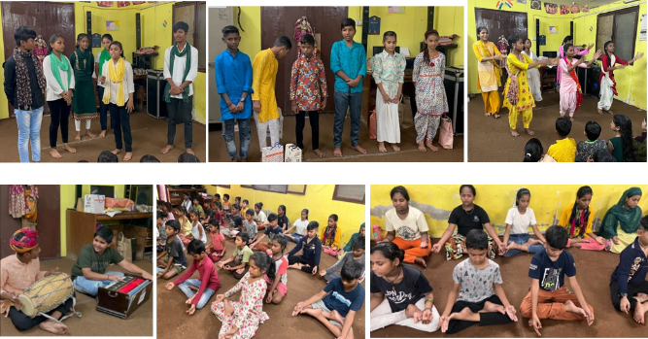

      - Competitions and Cultural Programs
We have also arranged many competitions and cultural programs. Competitions that were organised were:
• Power Point (PPT) Making Competitions
• Microsoft Paint Competition
• Essay Writing Competition
• Poster making Competition
• Speech Giving Competition
• Poem Recitation Competition

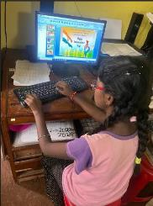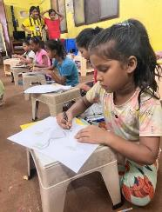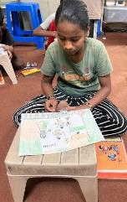

      - Art Programs
Various art performance programs were also organised as follows:
- Musical Performance
- Band Performance
- Dance Performance
- Bhawai Dance
- Role plays & Acts
- Poems Presentation

      - Summer Vacation Camp
During formal school summer vacation, the Trust supported the students to improve their foundational skills in general Mathematics & English.

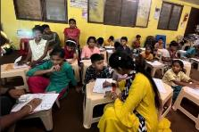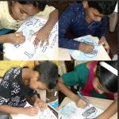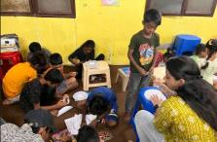

      - Outings

        - Movie Outing
Trust staff went on a Movie Outing with of our students on the occasion of National Cinema Day 2023.

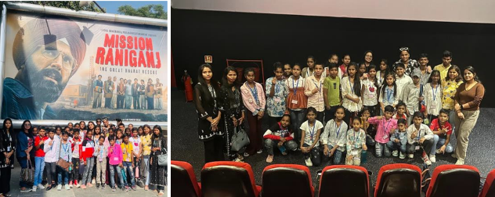

        - Picnic

On September 2023, 30 students went on a picnic to Mojoland, Sonipat. They were accompanied by 5 teachers.

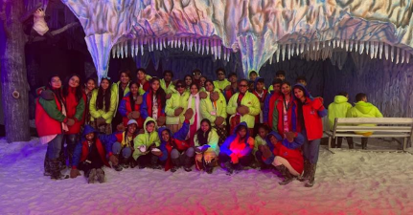

    - Other Key Highlights and Achievements

      - School Admissions Highlights

As a result of the successful coaching and other support that the Kalakar Trust provided:
- All 10th class students successfully passed and progressed to taking admission in the 11th class according to their preferred stream.
- New admissions were registered into the General Education Batches and Literacy Batches
- We have achieved the target of 100+ student attendance.
- The Trust facilitated admissions in government schools (online and offline) for students between the ages of 4 to 10 years.
- Teachers Ms Shivani, Ms Sushma, and Ms Nishrat conducted a survey in the community to restore the school alumni’s memory and of adult artists from the community. We have covered the four blocks for this purpose.

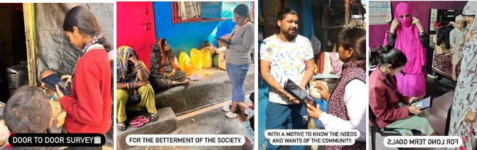

      - Computer and English Classes Highlights

- 10 students completed Basic and Advanced Computer certificate courses.
- Some students have started computer courses such as Tally ERP, Photoshop, and Coreldraw.
- 15 girls who attended the stitching class have started learning English and computer skills training.
- Regular updates are posted on our social media handles.

      - Literacy Batch

Many students of the Literacy batch are moved to more advanced classes once their level has been tested as passing. Many women who are homemakers have joined the literacy classes.

      - Special Batch

We have made a special batch for those students who never went to school or left school for different reasons. We have started supporting them beginning with the very basic level, the same as the literacy batch.

End of Report

